CO2 ASSESSMENT TOOL 1
SCENARIO-BASED REQUIREMENT ANALYSIS
Intelligent Disaster Emergency Response Platform
1. Introduction
1.1 Purpose
This Software Requirements Specification (SRS) describes the requirements of the Intelligent Disaster Emergency Response Platform. It defines what the system must do, who will use it, the information it stores, and the quality standards it must satisfy. It can guide development, testing, and future improvements.
1.2 Business Domain
The system belongs to disaster management and emergency response. It supports coordination during floods, earthquakes, cyclones, fires, and other emergencies. It brings incident reporting, severity-based prioritization, rescue-team dispatch, shelter information, and resource tracking into one platform.
1.3 Problem Description
During a disaster, emergency information may arrive through calls, messages, and separate agency systems. Reports can be duplicated or incomplete, high-risk cases may not be identified quickly, and rescue teams may not know the latest location or resource availability. These delays can waste time and put lives at risk.
The proposed platform provides a shared, real-time view of incidents and resources. It helps authorized staff identify urgent incidents, assign suitable teams, communicate status updates, and monitor the response until each incident is closed.
1.4 Objectives
- Allow citizens or authorized staff to report an emergency with location and incident details.
- Prioritize incidents using severity, urgency, and available information.
- Display incidents and response units on a map where map services are available.
- Help dispatchers assign rescue teams, medical units, and supplies.
- Maintain shelter capacity, location, and available resources.
- Send alerts and provide status updates to relevant users.
- Create reports and maintain an audit trail for accountability.
1.5 Stakeholders and Business Context
Stakeholder | Role / Need
Affected citizens | Report emergencies and receive updates or safety instructions.
Emergency dispatcher | Verify reports, prioritize incidents, and assign response teams.
Rescue teams | Receive assignments, navigate to incidents, and update progress.
Medical units | Receive medical emergency details and report availability.
Shelter/resource coordinators | Update shelter capacity, supplies, and resource status.
System administrator | Manage accounts, roles, configuration, and system access.
Disaster management authority | Monitor overall response and use reports for decisions.
2. Scope and System Overview
2.1 Scope of the System
The platform supports the emergency-response lifecycle from incident reporting to verification, prioritization, assignment, status monitoring, and closure. It provides role-based access so each user can view and update only the information needed for their role.
Included Features
- User registration or controlled account creation and secure login.
- Incident reporting with category, description, severity indicators, time, and location.
- Incident verification, duplicate review, prioritization, and status tracking.
- Map-based incident and team view, subject to map-service availability.
- Rescue-team and resource assignment, with availability checks.
- Shelter directory, capacity, and supply updates.
- Notifications, dashboards, reports, and audit logs.

Out of Scope
- Replacing emergency telephone numbers or official government command systems.
- Autonomous dispatch without human oversight.
- Guaranteeing that mobile networks, GPS, maps, or third-party notification services always work.
- Medical diagnosis, treatment decisions, or automatic legal decisions.
- Manufacturing or physically controlling rescue equipment.
2.2 System Context
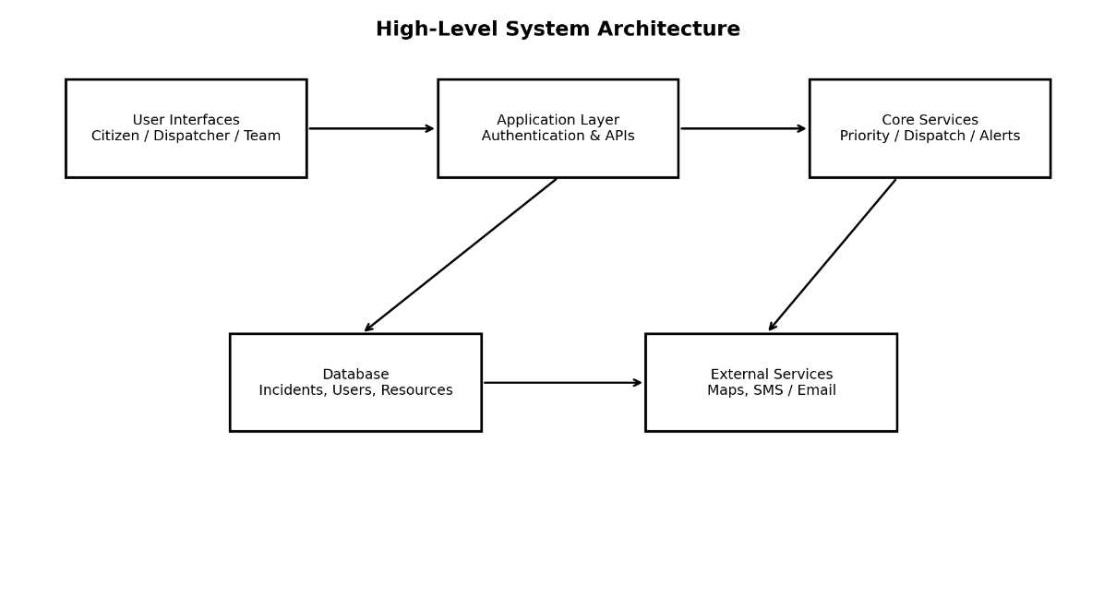

Figure 1. High-level architecture of the proposed platform.
2.3 Operating Environment
The system is intended to run as a web application accessible through modern browsers on desktops, tablets, and smartphones. A secure application server, database, internet or authorized network connection, and optional external map and notification services are required.
2.4 Users and Access
Role | Typical Permissions
Citizen | Submit incident, view own report status, receive alerts.
Dispatcher | Review reports, set priority, assign teams, change incident status.
Rescue team | View assigned incidents and update response progress.
Resource coordinator | Maintain shelters, supplies, and resource availability.
Administrator | Manage users, roles, system settings, and audit review.

3. Functional Requirements
Functional requirements describe the actions and services the platform must provide. Each requirement has a unique identifier for testing and traceability.
ID | Requirement | Priority
FR-01 | The system shall authenticate users and apply role-based permissions. | High
FR-02 | The system shall allow a citizen or authorized operator to submit an incident report. | High
FR-03 | Each report shall record incident type, description, time, location, and reporter reference where available. | High
FR-04 | The system shall validate required fields and show clear errors for incomplete reports. | High
FR-05 | The system shall allow authorized staff to verify, reject, or flag duplicate reports. | High
FR-06 | The system shall assign or recommend priority using severity and urgency indicators. | High
FR-07 | The system shall display incidents by status and priority in a dashboard. | High
FR-08 | The system shall display incident and response-unit locations on a map when location data and map service are available. | High
FR-09 | The dispatcher shall assign an available rescue team or resource to an incident. | High
FR-10 | The system shall prevent or warn against assigning a unit already marked unavailable. | High
FR-11 | Rescue teams shall view their assigned tasks and update status: accepted, en route, on scene, completed. | High
FR-12 | The system shall maintain shelter locations, capacity, occupancy, and available supplies. | Medium
FR-13 | The system shall send status alerts to relevant users through configured channels. | Medium
FR-14 | The system shall record incident history, assignment changes, and status updates. | High
FR-15 | The system shall generate summary reports by date, incident type, priority, location, and status. | Medium
FR-16 | Administrators shall create, deactivate, and manage user roles. | High
FR-17 | The system shall allow authorized staff to close an incident after response completion. | High
FR-18 | The system shall log important user actions for auditing and investigation. | High
3.1 Main Processing Rules
- Every incident must have a unique incident ID and creation timestamp.
- Critical incidents must be shown before lower-priority incidents, while authorized dispatchers retain final control.
- Only authorized roles may change priority, assign resources, or close incidents.
- A closed incident remains available for authorized review and reporting.
- The system must retain a history of important changes rather than silently overwriting them.

4. Non-Functional Requirements
Non-functional requirements define how well the platform should operate. The following targets are proposed design goals and should be confirmed with the disaster-management authority.
ID / Quality | Requirement / Acceptance Target
NFR-01 Performance | For normal operating load, 95% of common screens and searches should respond within 3 seconds, excluding slow external services.
NFR-02 Availability | Target at least 99.5% monthly service availability, excluding agreed maintenance; emergency fallback procedures must exist.
NFR-03 Security | Use encrypted connections, secure password storage, role-based access, session controls, and protection against common web attacks.
NFR-04 Privacy | Collect only necessary personal information and restrict access to sensitive location and contact details.
NFR-05 Reliability | Validate input, handle failures safely, prevent data corruption, and preserve confirmed incident records.
NFR-06 Scalability | Support growth in users, incidents, and simultaneous requests through scalable application services and database optimization.
NFR-07 Usability | Provide clear labels, simple forms, readable status indicators, and a mobile-friendly layout.
NFR-08 Maintainability | Use modular components, documented APIs, version control, and automated tests where practical.
NFR-09 Compatibility | Support current versions of major browsers and responsive use on mobile devices.
NFR-10 Recovery | Perform regular backups and define recovery objectives approved by the operating authority.
NFR-11 Auditability | Record user, action, timestamp, and relevant record ID for important changes.
NFR-12 Accessibility | Use sufficient contrast, keyboard-accessible controls, and understandable error messages.

4.1 Security and Safety Principles
- Use least-privilege access: users receive only the permissions needed for their work.
- Require confirmation before closing an incident or making other high-impact changes.
- Show when information is outdated or an external service is unavailable.
- Do not rely on automated priority alone; a trained dispatcher must be able to review and override it with a recorded reason.
- Keep backup and manual communication procedures for outages.
4.2 Quality Measures
The requirements are measurable where possible. Performance should be tested under an agreed load; access controls should be tested using different roles; backup recovery should be demonstrated; and usability should be checked with representative users.
5. Actors and Use Cases
5.1 Actors
Actor | Type | Main Interaction
Affected Citizen | Primary | Report an emergency, provide location/details, and check status.
Emergency Dispatcher | Primary | Verify incidents, prioritize cases, assign teams, and close incidents.
Rescue Team Member | Primary | Receive assignment, view location, and update response status.
Resource/Shelter Coordinator | Primary | Update shelter capacity, supplies, and resource availability.
System Administrator | Secondary / support | Manage users, roles, settings, and audit records.
Medical Unit | External operational actor | Receive medical assignments and report availability.
Map Service | External system | Provide map display and geocoding where available.
Notification Gateway | External system | Send SMS, email, or push notifications.
5.2 Major Use Cases
Use Case | Primary Actor | Outcome
UC-01 Report Incident | Citizen / Operator | A uniquely identified incident is saved.
UC-02 Verify Incident | Dispatcher | Report is verified, rejected, or flagged for review.
UC-03 Prioritize Incident | Dispatcher / System support | Incident receives a priority level and reason.
UC-04 View Map and Incidents | Dispatcher / Rescue Team | Authorized user sees relevant incidents and units.
UC-05 Assign Response Team | Dispatcher | Available team/resource is assigned.
UC-06 Update Response Status | Rescue Team | Progress is recorded and visible to authorized users.
UC-07 Manage Shelters and Supplies | Resource Coordinator | Capacity and inventory data are updated.
UC-08 Send Notification | System / Dispatcher | Relevant users receive an alert when a channel is available.
UC-09 Generate Reports | Dispatcher / Administrator | A filtered summary is produced.
UC-10 Manage Users | Administrator | Accounts and role permissions are maintained.
UC-11 Close Incident | Dispatcher | Completed incident is closed with a recorded outcome.
5.3 Use Case Diagram
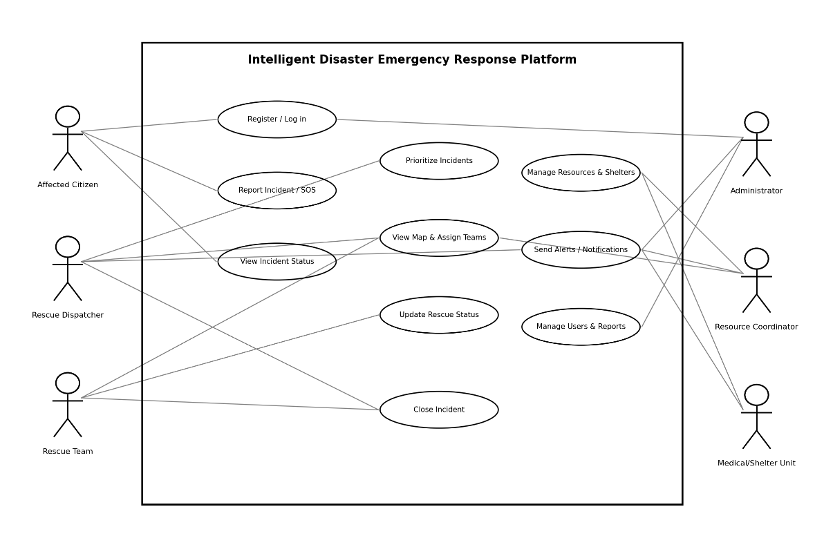

Figure 2. Use case diagram showing actors and major platform functions.
Note: The diagram is a high-level model. Detailed permissions and exceptional flows are specified in the use case descriptions.
6. Use Case Descriptions
6.1 UC-01: Report Incident
Field | Description
Primary actor | Affected citizen or authorized operator
Precondition | The platform is available; the user can access the reporting form.
Trigger | The user selects “Report Emergency”.
Main flow | 1. System displays the form. 2. User enters incident type, description, location, and contact details if available. 3. System validates mandatory fields. 4. System saves the report and creates an incident ID. 5. System confirms submission and displays the status.
Alternative flow | If location is unavailable, the user may enter a location description. If required data is missing, the system identifies the fields and requests correction.
Postcondition | Incident is stored with initial status “New” and an audit timestamp.
6.2 UC-03: Prioritize Incident
Field | Description
Primary actor | Emergency dispatcher
Precondition | An incident has been submitted and is visible to authorized staff.
Main flow | 1. Dispatcher opens the incident. 2. System shows severity indicators and available details. 3. System recommends a priority. 4. Dispatcher reviews the recommendation and confirms or overrides it. 5. System stores priority and reason and updates the queue.
Alternative flow | If details are incomplete, the incident is flagged for verification. If the priority is overridden, the dispatcher must enter a reason.
Postcondition | Priority is saved and the change is recorded in the audit history.
6.3 UC-05: Assign Response Team
Field | Description
Primary actor | Emergency dispatcher
Precondition | Incident is verified or eligible for dispatch; team information is available.
Main flow | 1. Dispatcher selects an incident. 2. System lists suitable available teams/resources. 3. Dispatcher selects a unit. 4. System confirms assignment and notifies the team. 5. Team acknowledges and updates progress.
Alternative flow | If no team is available, the system flags the incident as awaiting resources and alerts the dispatcher.
Postcondition | Assignment, timestamp, and assigned unit are saved.
6.4 UC-06: Update Response Status
Field | Description
Primary actor | Rescue team member
Precondition | The team is authenticated and has an assigned incident.
Main flow | Team opens assignment, selects the current status, adds notes if needed, and submits. The system saves the update and informs authorized users.
Alternative flow | If the connection fails, the user receives an error and the update is not falsely shown as saved.
Postcondition | Incident timeline reflects the latest confirmed status.

7. Data Requirements
The database must store accurate, consistent, and access-controlled information. Each record should have a unique identifier, creation time, and modification history where relevant.
Entity | Key Data Fields | Purpose
User | User_ID, name, contact, role, account_status | Identifies users and permissions.
Incident | Incident_ID, type, description, location, reported_time, severity, priority, status, reporter_ID | Stores emergency details and lifecycle.
Assignment | Assignment_ID, Incident_ID, Unit_ID, assigned_time, accepted_time, status | Connects incidents to response units.
Response Unit | Unit_ID, unit_type, current_location, availability, contact | Tracks rescue/medical team readiness.
Shelter | Shelter_ID, name, location, capacity, occupancy, status | Supports safe shelter selection.
Resource | Resource_ID, resource_type, quantity, location, availability | Tracks supplies and equipment.
Notification | Notification_ID, recipient_ID, incident_ID, channel, sent_time, delivery_status | Tracks communication attempts.
Audit Log | Log_ID, user_ID, action, record_ID, timestamp, change_summary | Supports accountability and investigation.

7.1 Data Validation Rules
- Incident_ID, User_ID, Unit_ID, and other primary keys must be unique.
- An assignment must reference an existing incident and response unit.
- Incident status and priority must use approved values, such as New, Verified, Assigned, In Progress, Resolved, and Closed.
- Shelter occupancy must not be negative and should not exceed capacity without an authorized warning or override.
- Timestamps must use a consistent time standard and be displayed in the user's local time where appropriate.
- Only authorized users may view personal contact details or modify protected records.
7.2 Relationship Overview
Relationship | Rule
User – Incident | One user may report many incidents; each incident may reference one reporter.
Incident – Assignment | One incident may have multiple assignment records over time.
Response Unit – Assignment | One unit may receive many assignments over time, subject to availability.
Shelter – Resource | A shelter may have multiple resource/inventory entries.
User – Audit Log | One user may generate many audit events.

7.3 Data Retention
Retention periods must follow the applicable organizational policy and law. Records needed for emergency review should be retained securely; unnecessary personal data should not be kept longer than required.
8. External Interface Requirements
Interface | Requirements
User interface | Responsive web screens for reporting, dashboards, maps, assignments, shelters, and administration.
Hardware / device | Smartphone, tablet, or computer with a browser; GPS capability is helpful but not mandatory.
Software interface | Application server communicates with a database using secure, validated queries and APIs.
Map service | May provide maps and location search; system must show a clear warning if unavailable.
Notification service | SMS, email, or push gateway may be used; delivery status should be recorded when provided.
Network | Secure HTTPS connection; system should handle timeouts and show whether a submission succeeded.
Accessibility | Forms should use clear labels, keyboard access, readable text, and visible error messages.
9. System Features and Incident Workflow
Feature | Description | Expected Benefit
Incident reporting | Structured emergency form and unique incident ID. | Reduces missing details and confusion.
Priority management | Severity-based queue with dispatcher review. | Helps urgent cases receive attention first.
Map and dispatch | Map view and availability-aware team assignment. | Improves coordination and location awareness.
Shelter/resource management | Capacity, occupancy, supplies, and availability records. | Supports informed allocation of resources.
Notifications | Alerts on assignment and status changes. | Keeps teams and relevant users informed.
Dashboards and reports | Live summaries and filtered historical reports. | Supports monitoring and planning.
Audit trail | Records key actions and changes. | Improves transparency and accountability.

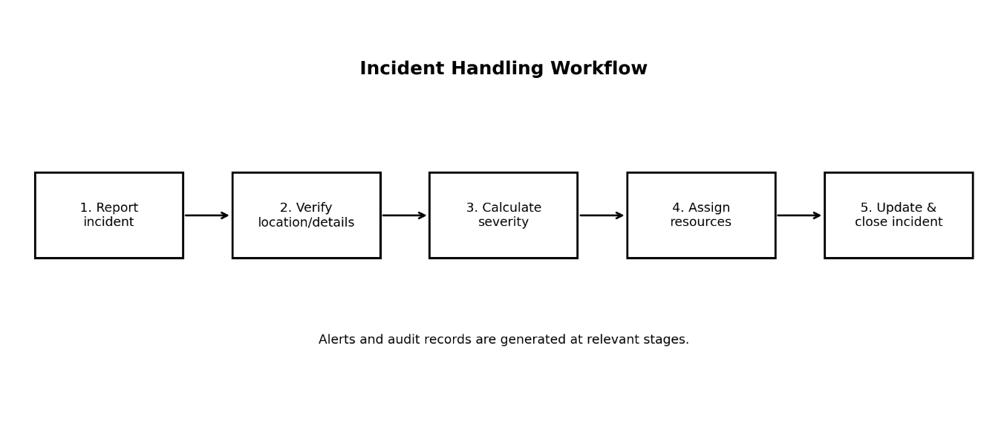
Figure 3. Typical incident-handling workflow.
9.1 Error Handling
The system must display understandable messages for invalid forms, failed logins, unavailable map/notification services, network errors, and unsuccessful saves. It must never display a report as successfully submitted until the server confirms that it has been saved.
10. Assumptions and Constraints
10.1 Assumptions
- Citizens or authorized operators can provide at least some incident details.
- Dispatchers and rescue teams are trained and have authorized accounts.
- The operating authority defines incident categories, priority levels, and escalation rules.
- Map, GPS, SMS, and email services may be available but are not guaranteed.
- Shelter and resource coordinators update availability information regularly.
- The platform supplements, rather than replaces, existing official emergency procedures.
10.2 Constraints
Constraint Type | Constraint
Technical | Network outages, device limitations, inaccurate GPS, and third-party service failures may affect operation.
Operational | Users need training; data quality depends on timely updates from field teams and coordinators.
Economic | Hosting, maps, messaging, security, backup, and maintenance have ongoing costs.
Legal / privacy | Personal data, location data, and records must be handled under applicable privacy, security, and emergency-management rules.
Time-related | Development must be planned in stages; critical reporting and dispatch functions should be prioritized first.
Safety | Automated priority recommendations must be reviewed by trained personnel; system failure must not remove manual emergency procedures.
11. Requirement Completeness and Consistency Validation
The requirements were reviewed against the stakeholder needs, system scope, functional and non-functional lists, use cases, and data model.
Validation Check | Result / Improvement
Completeness | Citizen reporting, verification, prioritization, dispatch, status updates, resource/shelter tracking, notifications, administration, and reporting are covered.
Consistency | Incident statuses, roles, and data entities are used consistently across requirements and use cases.
Ambiguity | Priority rules, performance load, retention period, and recovery objectives need approval by the operating authority.
Redundancy | Notifications and status updates are related but distinct: one records progress, the other communicates selected events.
Feasibility | External maps and notification services are optional dependencies; fallback and manual procedures are required.
Testability | Requirements use clear actions and measurable targets where possible; each FR/NFR can be linked to a test case.
Security | Role permissions, audit logs, encryption, and data minimization are included; security testing is required.
Usability | Mobile-friendly screens, readable status, and clear error messages are specified.

11.1 Suggested Improvements
- Confirm measurable service targets with stakeholders before development.
- Conduct interviews or workshops with dispatchers, rescue teams, medical units, and shelter coordinators.
- Create a traceability matrix linking each requirement to a stakeholder need, use case, and test case.
- Test the system under peak load and simulate network or external-service failures.
- Review privacy, accessibility, and security requirements with relevant experts.

12. Conclusion
The Intelligent Disaster Emergency Response Platform provides a structured way to report emergencies, prioritize incidents, coordinate rescue teams, manage resources, and monitor outcomes. This SRS identifies the system scope, functional and non-functional requirements, actors, use cases, data, interfaces, assumptions, and constraints. Requirement validation highlights areas that need stakeholder confirmation before implementation. The document can serve as a foundation for design, development, testing, and future enhancement.
Requirement Traceability Summary
Stakeholder Need | Related Requirements / Use Cases
Report an emergency | FR-02 to FR-04; UC-01
Identify urgent cases | FR-05 to FR-07; UC-02 and UC-03
Coordinate rescue teams | FR-08 to FR-11; UC-04 to UC-06
Track shelters and supplies | FR-12; UC-07
Communicate updates | FR-13 to FR-14; UC-08
Monitor and govern system | FR-15 to FR-18; UC-09 to UC-11

